Chapter 2: Describing Location in a Distribution

Objectives: Students will:
Be able to compute measures of relative standing for individual values in a distribution. This includes standardized values z-scores and percentile ranks.
Use Chebyshev’s Inequality to describe the percentage of values in a distribution within an interval centered at the mean.
Demonstrate an understanding of a density curve, including its mean and median.
Demonstrate an understanding of the Normal distribution and the 68-95-99.7 Rule.
Use tables and technology to find (a) the proportion of values on an interval of the Normal distribution and (b) a value with a given proportion of observations above or below it.
Use a variety of techniques, including construction of a normal probability plot, to assess the Normality of a distribution.

AP Outline Fit:
I. Exploring Data: Describing patterns and departures from patterns (20%–30%)
B. Summarizing distributions of univariate data
3. Measuring position: . . . percentiles, standardized scores (z-scores)
III. Anticipating Patterns: Exploring random phenomena using probability and simulation (20%–30%)
C. The normal distribution
1. Properties of the normal distribution
2. Using tables of the normal distribution
3. The normal distribution as a model for measurements

What You Will Learn:

- Measures of Relative Standing
  - Find the standardized value (z-score) of an observation. Interpret z-scores in context
  - Use percentiles to locate individual values within distributions of data
  - Apply Chebyshev’s inequality to a given distribution of data
- Density Curves
  - Know that areas under a density curve represent proportions of all observations and that the total area under a density curve is 1
  - Approximately locate the median (equal-areas point) and the mean (balance point) on a density curve
  - Know that the mean and median both lie at the center of a symmetric density curve and that the mean moves farther toward the long tail of a skewed curve
- Normal Distribution
  - Recognize the shape of Normal curves and be able to estimate both the mean and standard deviation from such a curve
  - Use the 68-95-99.7 rule (Empirical Rule) and symmetry to state what percent of the observations from a Normal distribution fall between two points when the points lie at the mean or one, two, or three standard deviations on either side of the mean
  - Use the standard Normal distribution to calculate the proportion of values in a specified range and to determine a z-score from a percentile
  - Given that a variable has the Normal distribution with mean μ and standard deviation σ, use Table A and your calculator to
    - determine the proportion of values in a specified range
    - calculate the point having a stated proportion of all values to the left or to the right of it
- Assessing Normality
  - Plot a histogram, stemplot, and/or boxplot to determine if a distribution is bell-shaped
  - Determine the proportion of observations within one, two, and three standard deviations of the mean and compare with the 68-95-99.7 rule (Empirical rule) for Normal distributions
  - Construct and interpret Normal probability plots
Section 2.1: Measures of Relative Standing and Density Curves

Knowledge Objectives: Students will:
Explain what is meant by a standardized value.
Define Chebyshev’s inequality, and give an example of its use.
Explain what is meant by a mathematical model.
Define a density curve.
Explain where the median and mean of a density curve can be found.

Construction Objectives: Students will be able to:
Compute the z-score of an observation given the mean and standard deviation of a distribution.
Compute the p^{th} percentile of an observation.
Describe the relative position of the mean and median in a symmetric density curve and in a skewed density curve.

Vocabulary:
Chebyshev’s Inequality – rule of thumb for percentage of observations in any distribution within in specified standard deviations from the mean
Density Curve – the curve that represents the proportions of the observations; and describes the overall pattern
Mathematical Model – an idealized representation
Median of a Density Curve – is the “equal-areas point” and denoted by M or Med
Mean of a Density Curve – is the “balance point” and denoted by μ (Greek letter mu)
Normal Curve – a special symmetric, mound shaped density curve with special characteristics
P^{th} Percentile – the observation’s percentage location in the sample’s ordered list
Standard Deviation of a Density Curve – is denoted by σ (Greek letter sigma)
Standardized Value – a z score
Standardizing – converting data from original values to standard deviation units
Uniform Distribution – a symmetric rectangular shaped density distribution
Z-score – a standardized value indicating the number of standard deviations about or below the mean

Key Concepts:

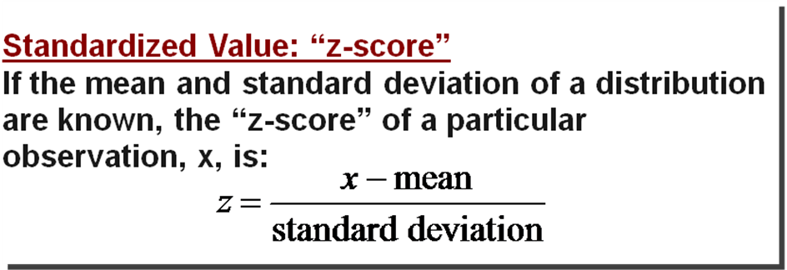

- Another measure of relative standing is a percentile rank
- p^{th} percentile: Value with p % of observations below it
  - median = 50th percentile {mean=50th %ile if symmetric}
  - Q1 = 25th percentile
  - Q3 = 75th percentile
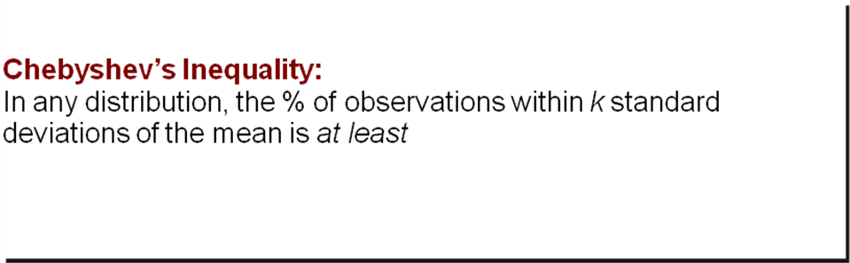
Examples:

1: Summary of the scores listed below:
According to Minitab, the mean test score was 80 while the standard deviation was 6.07 points.
79 | 81 | 80 | 77 | 73 | 83 | 74 | 93 | 78 | 80 | 75 | 67 | 73
77 | 83 | 86 | 90 | 79 | 85 | 83 | 89 | 84 | 82 | 77 | 72
Julia’s score was above average. Her standardized z-score is:

    - Kevin scored a 72, what is his z-score?

    - Katie scored an 80, what is her z-score?

2: Standardized values can be used to compare scores from two different distributions
Statistics Test: mean = 80, std dev = 6.07
Chemistry Test: mean = 76, std dev = 4
Jenny got an 86 in Statistics and 82 in Chemistry.
On which test did she perform better?

3: What is Jenny’s percentile?

4: Determine which is the mean, median and mode in the following:
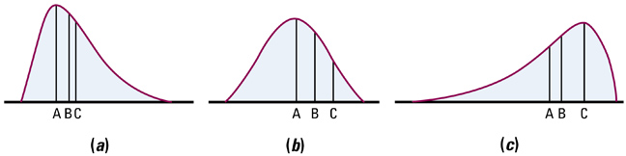
5: A random number generator on calculators randomly generates a number between 0 and 1. The random variable X, the number generated, follows a uniform distribution
- Draw a graph of this distribution
- What is the percentage (0<X<0.2)?
- What is the percentage (0.25<X<0.6)?
- What is the percentage > 0.95?
- Use calculator to generate 200 random numbers

Homework:
Day 1: pg 118-9 probs 2-2, 3, 4, pg 122-123 probs 2-7, 8
Day 2: pg 128-9 probs 2-9, 10, 12, 13, pg 131-133 probs 15, 18
Section 2.2: Normal Distributions

Knowledge Objectives: Students will:
Identify the main properties of the Normal curve as a particular density curve.
List three reasons why normal distributions are important in statistics.
Explain the 68-95-99.7 rule (the empirical rule).
Explain the notation N(µ,σ ) (Normal notation).
Define the standard Normal distribution.

Construction Objectives: Students will be able to:
Use a table of values for the standard Normal curve (Table A) to compute
The proportion of observations that are less than a given z-score
The proportion of observations that are greater than a given z-score
The proportion of observations that are between two give z-scores
The value with a given proportion of observations above or below it (inverse Normal).
Use a table of values for the standard Normal curve to find the proportion of observations in any region given any Normal distribution (i.e., given raw data rather than z-scores).
Use technology to perform Normal distribution calculations and to make Normal probability plots.

Vocabulary:
68-95-99.7 Rule (or Empirical Rule) – given a density curve is normal (or population is normal), then the following is true:
within plus or minus one standard deviation is 68% of data
within plus or minus two standard deviation is 95% of data
within plus or minus three standard deviation is 99.7% of data
Inverse Normal – calculator function that allows you to find a data value given the area under the curve (percentage)
Normal curve – special family of bell-shaped, symmetric density curves that follow a complex formula
Standard Normal Distribution – a normal distribution with a mean of 0 and a standard deviation of 1

Key Concepts:
Properties of the Normal Density Curve
- It is symmetric about its mean, μ
- Because mean = median = mode, the highest point occurs at x = μ
- It has inflection points at μ – σ and μ + σ
- Area under the curve = 1
- Area under the curve to the right of μ equals the area under the curve to the left of μ, which equals ½
- As x increases without bound (gets larger and larger), the graph approaches, but never reaches the horizontal axis (like approaching an asymptote). As x decreases without bound (gets larger and larger in the negative direction) the graph approaches, but never reaches, the horizontal axis.
- The Empirical Rule applies

TI-83 Normal Distribution functions:

#1: normalpdf pdf = Probability Density Function
This function returns the probability of a single value of the random variable x. Use this to graph a normal curve. Using this function returns the y-coordinates of the normal curve.
Syntax: normalpdf (x, mean, standard deviation)
#2: normalcdf cdf = Cumulative Distribution Function
This function returns the cumulative probability from zero up to some input value of the random variable x. Technically, it returns the percentage of area under a continuous distribution curve from negative infinity to the x. You can, however, set the lower bound.
Syntax: normalcdf (lower bound, upper bound, mean, standard deviation)
#3: invNorm( inv = Inverse Normal Probability Distribution Function
This function returns the x-value given the probability region to the left of the x-value.
(0 < area < 1 must be true.) The inverse normal probability distribution function will find the precise value at a given percent based upon the mean and standard deviation.
Syntax: invNorm (probability, mean, standard deviation)

(the above take from http://mathbits.com/MathBits/TISection/Statistics2/normaldistribution.htm)

We can use -E99 for negative infinity and E99 for positive infinity.

Example 1: A random number generator on calculators randomly generates a number between 0 and 1. The random variable X, the number generated, follows a uniform distribution
- Draw a graph of this distribution

- What is the P(0<X<0.2)?

- What is the P(0.25<X<0.6)?

- What is the probability of getting a number > 0.95?

- Use calculator to generate 200 random numbers

Example 2: A random variable x is normally distributed with μ=10 and σ=3.

- Compute Z for x₁ = 8 and x₂ = 12

- If the area under the curve between x₁ and x₂ is 0.495, what is the area between z₁ and z₂?

Example 1: Determine the area under the standard normal curve that lies to the left of
- Z = -3.49

- Z = -1.99

- Z = 0.92

- Z = 2.90

Example 2: Determine the area under the standard normal curve that lies to the right of
- Z = -3.49

- Z = -0.55

- Z = 2.23

- Z = 3.45

Example 3: Find the indicated probability of the standard normal random variable Z.
- P(-2.55 < Z < 2.55)

- P(-0.55 < Z < 0)

- P(-1.04 < Z < 2.76)

Example 4:
- Find the Z-score such that the area under the standard normal curve to the left is 0.1.

- Find the Z-score such that the area under the standard normal curve to the right is 0.35.
Example 1: For a general random variable X with μ = 3 and σ = 2
- Calculate Z

- Calculate P(X < 6)

Example 2: For a general random variable X with μ = -2 and σ = 4
- Calculate Z

- Calculate P(X > -3)

Example 3: For a general random variable X with μ = 6 and σ = 4
calculate P(4 < X < 11)

Example 4: For a general random variable X with μ = 3 and σ = 2
find the value x such that P(X < x) = 0.3

Example 5: For a general random variable X with μ = –2 and σ = 4
find the value x such that P(X > x) = 0.2

Example 6: For random variable X with μ = 6 and σ = 4. Find the values that contain 90% of the data around μ

Homework:
Day 1: pg 137 probs 2-24, 25 pg 142 probs 2-29, 30
Day 2: pg 147 probs 2-32, 33, 34 pg 154-156 probs 2-37, 38, 39
Chapter 2: Review

Objectives: Students will be able to:
Summarize the chapter
Define the vocabulary used
Know and be able to discuss all sectional and chapter knowledge objectives
Be able to do all sectional and chapter construction objectives
Successfully answer any of the review exercises

Vocabulary: None new

Homework: pg 162 – 163; problems 2.51 – 2.59

